Install docker on EC2 and explore the docker commands (docker images, containers, volumes, network).

**Solution:-**

Launching EC2 instance in AWS Console

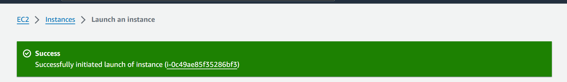

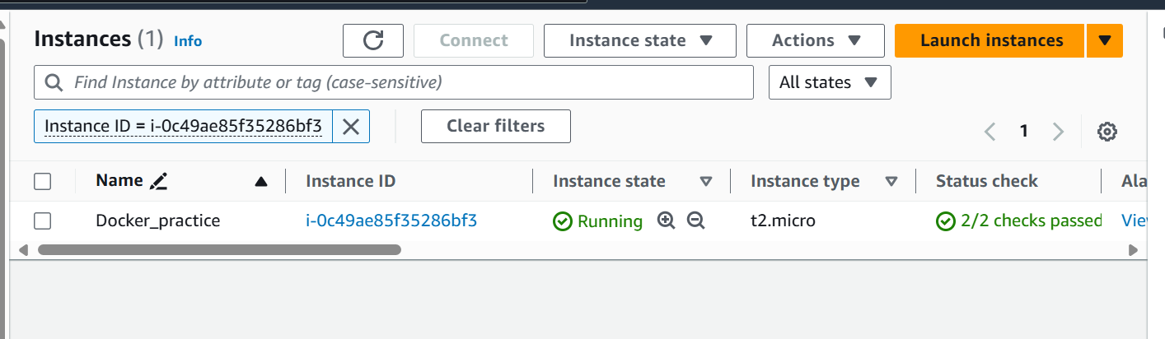

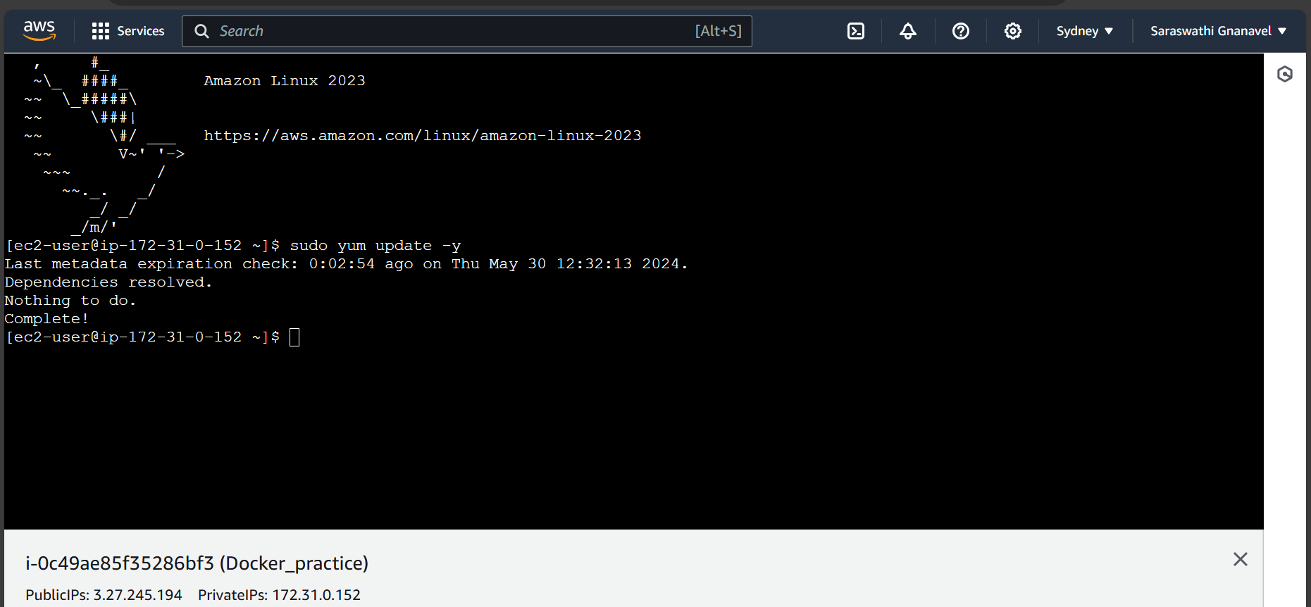

Installing Docker in AWS EC2 service

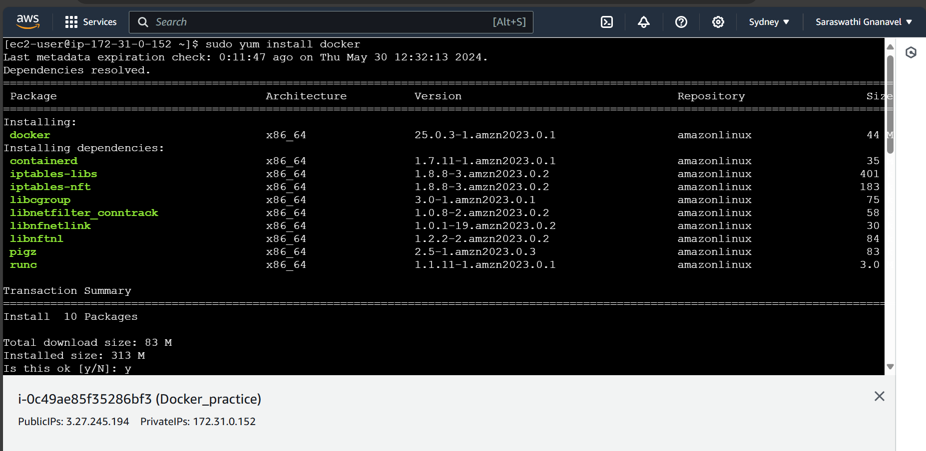

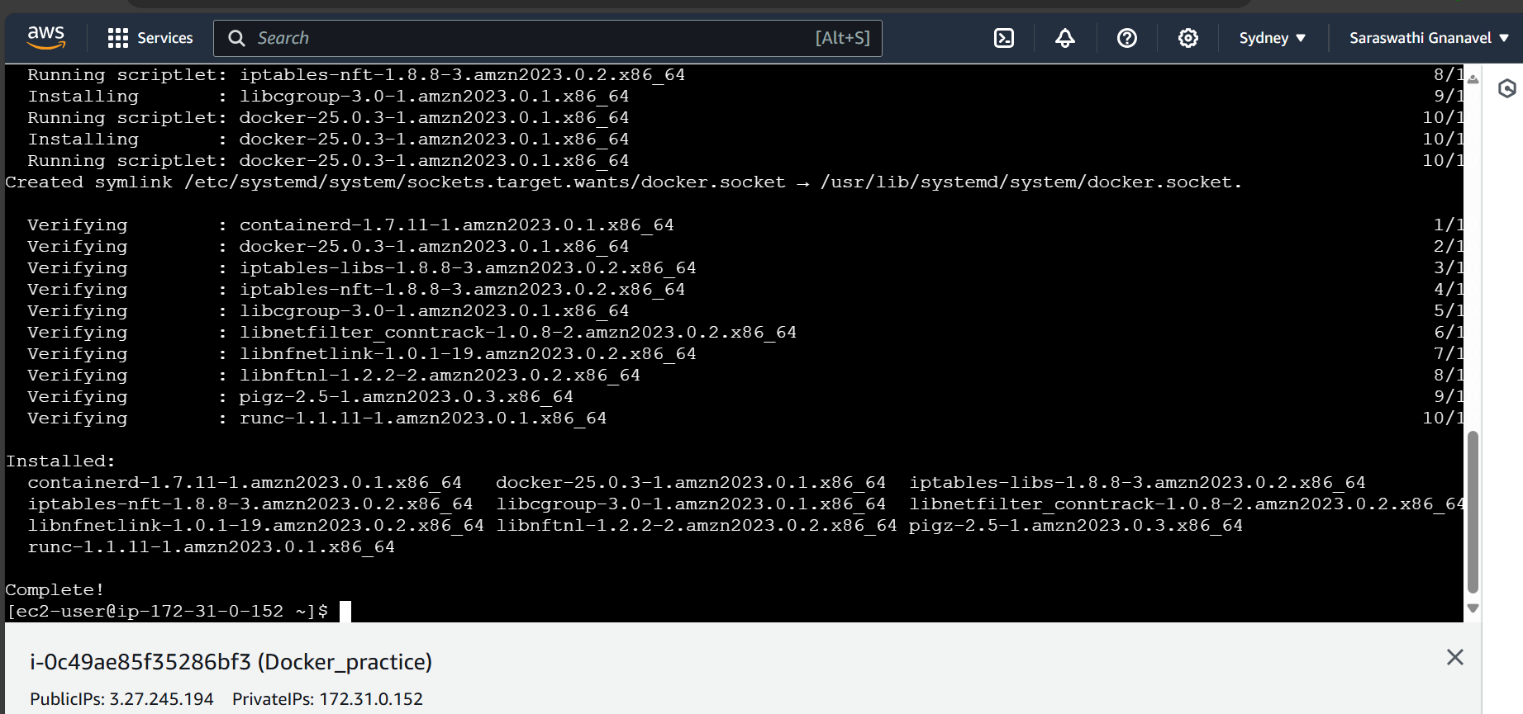

Starting the docker

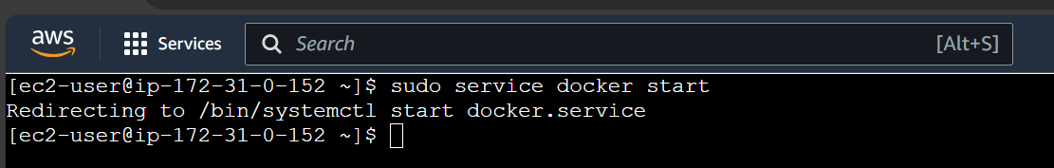

Enabling the Docker service



Adding the ec2-user to the docker group so you can execute Docker commands without using sudo

Cmd:- sudo usermod -a -G docker ec2-user and Refresh the instance

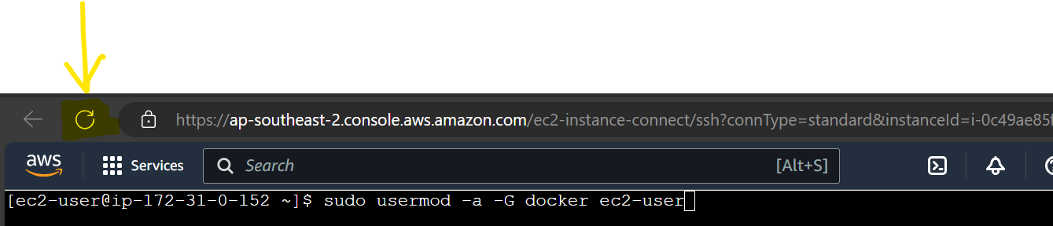

Verifying that the ec2-user can run Docker commands without sudo using docker info command

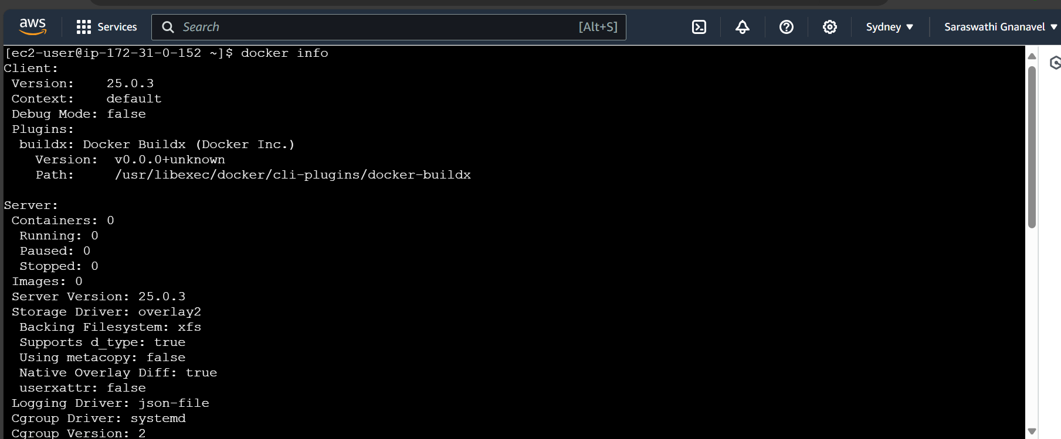

Creating a code file(File name is index.html)

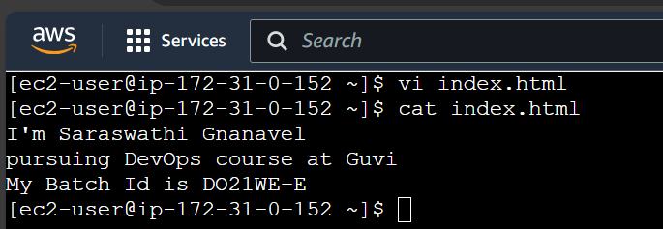

Creating Dockerfile

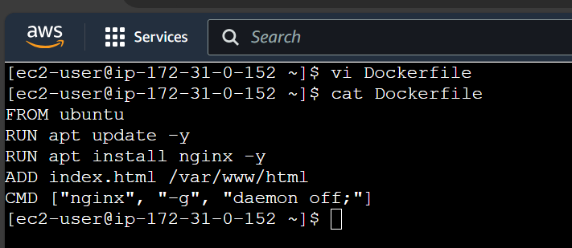

Building image using docker file

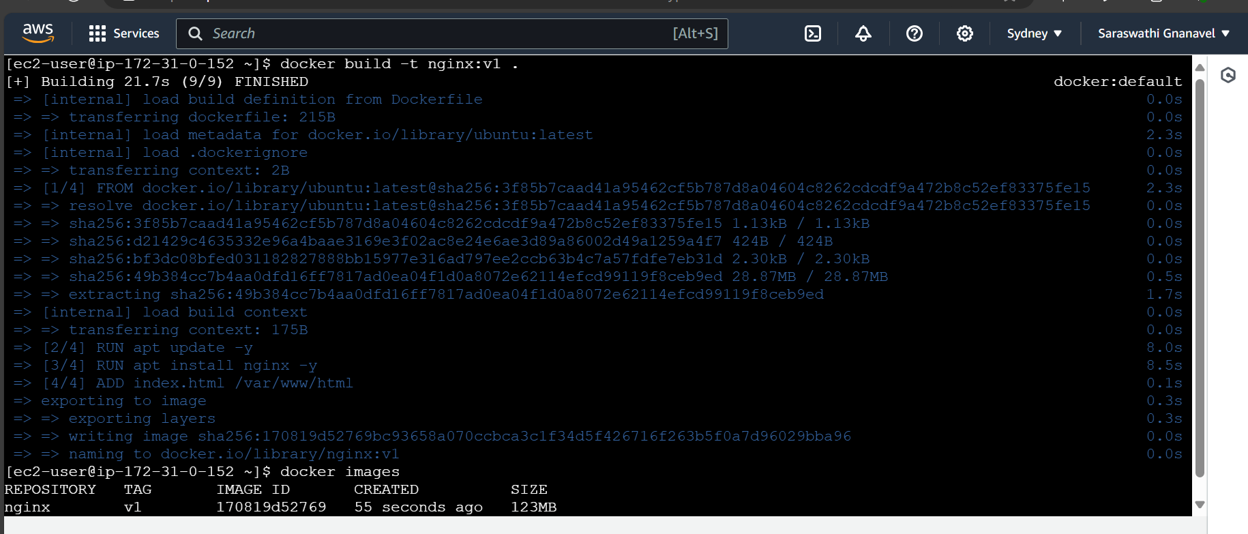

Running the image as container

